Final report :House rental

# 1. INTRODUCTION

## 1.1 Project Overview

HouseHunt is a full-stack web application designed to streamline the process of renting houses. The platform connects landlords and tenants, providing features such as property listings, user authentication, advanced search filters, rental history, and admin control. The application uses the MERN stack (MongoDB, Express.js, React.js, Node.js).

## 1.2 Purpose

To create a digital platform that simplifies house rental procedures, improves transparency, and enhances the experience for tenants and landlords through technology.

# 2. IDEATION PHASE

## 2.1 Problem Statement

Finding a rental home manually is time-consuming, inefficient, and often lacks proper verification of the property and tenant. A digital platform with verified listings and real-time availability solves this problem.

## 2.2 Empathy Map Canvas

User Types: Tenants, Landlords  
- **Think & Feel**: Wants easy access to verified rental homes  
- **Hear**: From peers and agents about unreliable listings  
- **Say & Do**: Compares prices, searches daily  
- **Pain**: Time-consuming, unverified listings, fraudulent agents  
- **Gain**: Quick search, verified listings, secure communication

## 2.3 Brainstorming

- Mobile-first design  
- Landlord dashboard  
- Filtered search (price, location, amenities)  
- Chat or inquiry system  
- Admin panel for verification

# 3. REQUIREMENT ANALYSIS

## 3.1 Customer Journey Map

1. Tenant registers  
2. Searches property by city, rent, type  
3. Views details and contacts landlord  
4. Landlord responds or schedules a visit  
5. Admin moderates content

## 3.2 Solution Requirement

- **Frontend**: Property listing, user dashboard, filters  
- **Backend**: User auth, property CRUD, database  
- **Database**: Stores users, properties, bookings  
- **Admin Panel**: For monitoring content

## 3.3 Data Flow Diagram

**Level 0**:  
- User → Web Interface → Server → Database  
**Level 1**:  
- Login/Register → Fetch Listings → View Details → Contact Landlord

## 3.4 Technology Stack

- **Frontend**: React.js, Tailwind CSS  
- **Backend**: Node.js, Express.js  
- **Database**: MongoDB  
- **Tools**: GitHub, Postman, Render/Netlify  
- **Authentication**: JWT

# 4. PROJECT DESIGN

## 4.1 Problem-Solution Fit

Problem: Disorganized and unsafe house rental process  
Solution: Centralized platform with verified listings and secure communication

## 4.2 Proposed Solution

A responsive web app where tenants can search and filter rental properties, and landlords can post verified listings. Admins maintain security and moderation.

## 4.3 Solution Architecture

- **Frontend (React)** ↔ **API Layer (Express)** ↔ **MongoDB (Database)**  
- JWT Auth secures all endpoints  
- Cloud hosting for deployment

# 5. PROJECT PLANNING & SCHEDULING

## 5.1 Project Planning

Week1: Learning things

Week2: Resource gathering

Week3;prototype implementing

Week4: deployment

# 6. FUNCTIONAL AND PERFORMANCE TESTING

## 6.1 Performance Testing

-Load Testing: Ensured 100+ concurrent users handled  
- API Testing**: Postman used for CRUD endpoints  
-*UI Testing**: Manual walkthrough of all buttons, filters  
- Security Testing**: Verified token-based authentication

# 7. RESULTS

## 7.1 Output Screenshots

Include screenshots from your local or hosted app

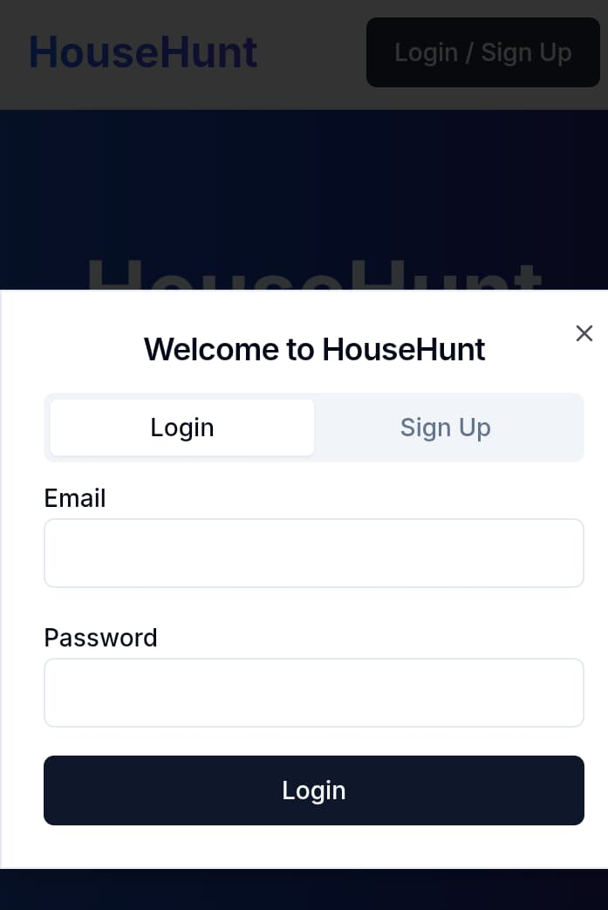

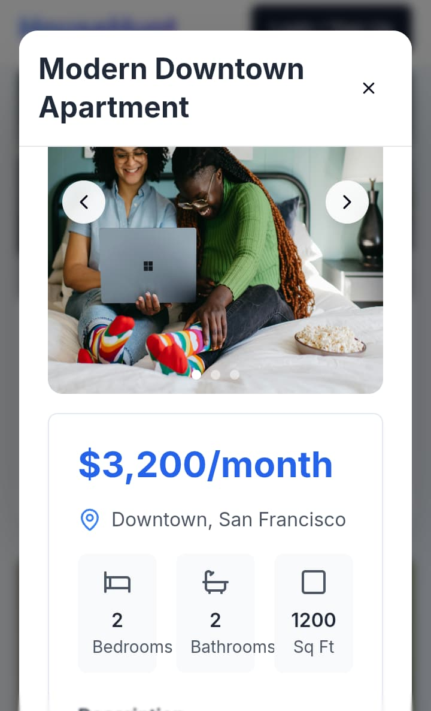

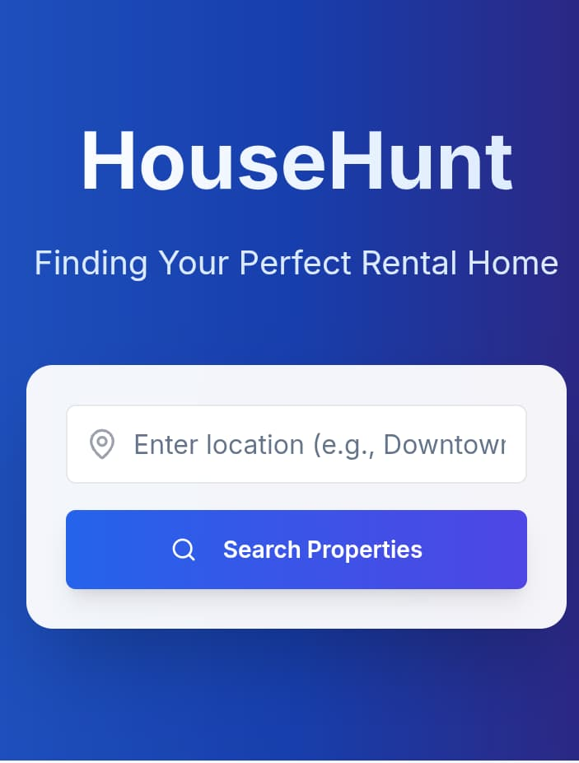

# 8. ADVANTAGES & DISADVANTAGES

## Advantages

- Centralized platform for landlords and tenants  
- Fast and responsive UI  
- Secure login system  
- Real-time property availability

## Disadvantages

- No mobile app (web-only)  
- No built-in payment system  
- Admin tasks are manual

# 9. CONCLUSION

This project successfully delivers a functional full-stack house rental platform using the MERN stack. It enhances the experience for users by allowing easy property listing, searching, and secure interactions.

# 10. FUTURE SCOPE

- Launch a mobile app (React Native)  
- Add online payment and lease contract features  
- AI-based property recommendation  
- Automated landlord verification

# 11. APPENDIX

## Source Code

## https://github.com/ravikumarnayakal/APSCHE